**CMSC 451 Project 1**

The first project involves benchmarking the behavior of Java implementations of one of the following sorting algorithms, bubble sort, selection sort, insertion sort, Shell sort, merge sort, quick sort or heap sort. You must post your selection in the "Ask the Professor" conference. No more than five students may select any one algorithm.

You must write the code to perform the benchmarking of the algorithm you selected. Your program must include both an iterative and recursive version of the algorithm. You do not have to write the sorting algorithms yourself, you may take them from some source, but you must reference your source.

You must identify some critical operation to count that reflects the overall performance and modify each version so that it counts that operation. In addition to counting critical operations you must measure the actual run time.

In addition, you should examine the result of each call to verify that the data has been properly sorted to verify the correctness of the algorithm. If the array is not sorted, an exception should be thrown.

It should also randomly generate data to pass to the sorting methods. It should produce 50 data sets for each value of n, the size of the data set and average the result of those 50 runs. The exact same data must be used for the iterative and the recursive algorithms. It should also create 10 different sizes of data sets. Choose sizes that will clearly demonstrate the trend as n becomes large.

You should also calculate the coefficient of variance of the critical operation counts and time measurement for the 50 runs of each data set size as a way to gauge the data sensitivity of the algorithm.

Your program must be written to conform to the following design:

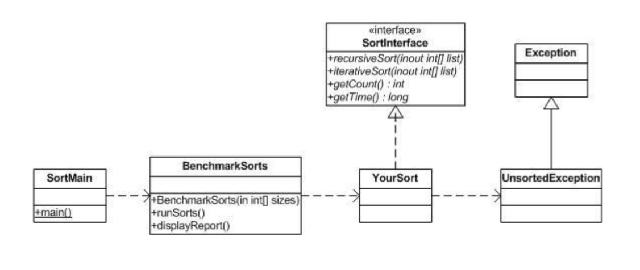Your output should look as follows:

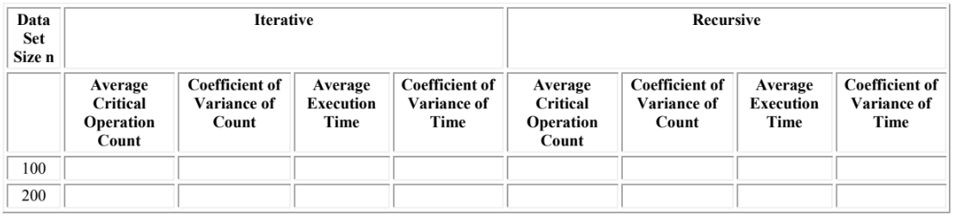

The data set sizes above are examples. You are to select the actual data set sizes. On the due date for project 1, you are to submit a .zip file that includes the source code of your complete program. All the classes should be in the default package.

You must research the issue of JVM warm-up necessary for properly benchmarking Java programs and ensure that your code performs the necessary warm-up so the time measurements are accurate.